

**Byte-Coders Project Documentation**

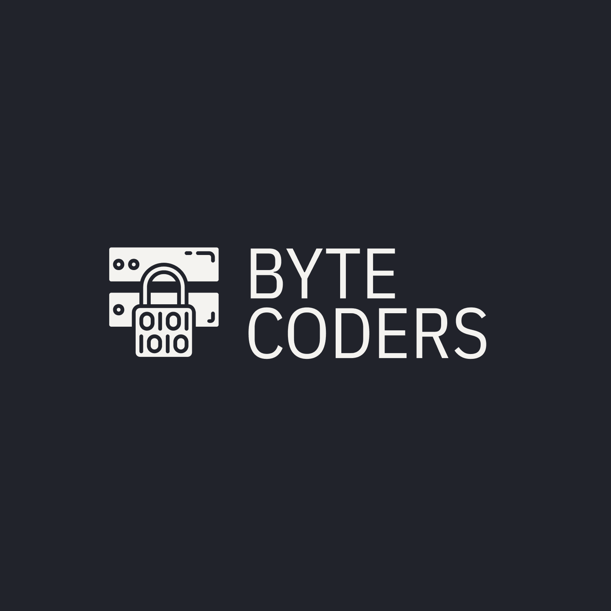

**Project Overview**

**Team Name: Byte-Coders**

**The Byte-Coders team is excited to present our collaborative project, which revolves around the theme of banking and finance. Our goal is to develop a robust application that addresses key financial management challenges, offering users a seamless experience in managing their finances.**

**Project Objectives**

**User-Friendly Interface: Our (Deisgner) with the help of the (Front-End) made an appealing UI for all users!**

**Secure Transactions: Our (Front-end/Back-End) have developed a robust log in system to ensure the safety of our users!**

**Comprehensive Features: Include functionalities such as account management, transaction tracking, budgeting tools, and financial analytics.**

**Scalability: Design the application to handle a growing user base and increasing data loads without compromising performance.**

**Project Features**

**Account Management: Users can create and manage multiple accounts, view budget, and access their income.**

**Transaction Tracking: Automatically categorize transactions to help users understand their spending habits.**

**Budgeting Tools: Users can set their income and expence to see their budget.**

**Financial Insights: Generate a staistics of the user data so they are on the right tack.**

**Secure Authentication: Utilize advanced authentication methods to protect user accounts.**

**Team Activities**

**(Scrum Trainer) Borislav Petkov - Made the documentation**

**(Front-End/Back-End)Ivailo Lalev – Scripted the application using c++ and python, made the verification system and the main functions!**

**(Front-End)Simeon Kalamerov – Create a site for the project and contributed to the design , and the over all program idea!**

**(Designer)Stilyan Duligerov – Made parts of the design.**

**Development Process**

**The Byte-Coders main scripter (Front-end/Back-end) ensured the application run smoothly  
Our Front-end developer ensured the application have a site so it’s easily accesable!  
 improvement. Key stages include:**

**Planning: Define project scope and deliverables.**

**Design: Create wireframes and design prototypes.**

**Implementation: Develop features in iterative cycles.**

**Testing: Conduct thorough testing to identify and resolve issues.**

**Deployment: Launch the application and monitor performance.**

**Contribution Guidelines**

**We welcome contributions from all team members and collaborators. Please follow these guidelines:**

**Fork the Repository: Create a personal copy of the project to work on.**

**Create a Branch: For each feature or bug fix, create a new branch from main.**

**Make Changes: Implement your changes and commit them with clear messages.**

**Pull Request: Submit a pull request to the main branch for review.**

**Conclusion**

**The Byte-Coders scripter team is committed to delivering a high-quality financial management application that meets the needs of our users. And our other part of the team is contributing to the over all successes of the team! We look forward to your feedback and collaboration as we progress on this exciting project.**